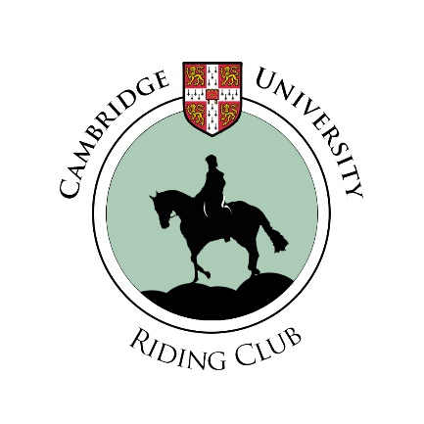
NOVEMBER NEWSLETTER
Over Summer
Team
Novice Team
RDA
Stash
Dates for your diary

Facebook page:
https://www.facebook.com/groups/5102278702/
Twitter:
@Cam_Equestrian
Website:
http://www.srcf.ucam.org/curiding/
Contact:
c.u.riding@sport.cam.ac.uk

Dear CURC,

Welcome back to Cambridge, I am sure that you are all now in full swing and busy with everything Michaelmas term has to offer. Whether this is your first Michaelmas here in Cambridge, or the umpteenth, I hope that you are enjoying yourself and of course that you have managed to fit in some riding!
There is lots to report, from what we’ve all been up to over the summer to how our links with the local RDA are progressing and how all our teams are getting on. We’ve had the first committee meeting, the Fresher’s Fair, our Membership Squash, Team Trials, Tea and Cake meet ups, a yoga workshop... and the list just keeps on growing with many dates for your diary – please see the last page for a term card so that you can fill up your diary!
Here is a snippet of what has been happening – enjoy reading and let me know of anything exciting you get up to for the next newsletter.

Hannah Clifford
CURC President 2014-2015

OVER SUMMER
We sent out our first Members Survey to get some feedback and help us decide where to focus our organising efforts. If anyone would like to see the full results they will be up on the website under ‘Documents’ but here is a brief run through the most popular options and what we have done about them:
- Beach ride. This is going to take place as our May Week event.
- Annual Dinner. This will be in week 6 of Lent Term as a formal dinner at a college with Alumnae invited back to join us.
- Hacking. This is proving tricky as we already have a lot of slots at the two stables and the weather and light levels are now against us. However we are looking into trying a different stables purely for hacking so we will keep you updated.
- Side saddle. Put the date in your diary – on SUNDAY 18th JANUARY Emily has organised for us to try going sideways to find out what it’s all about. I’m excited and plenty of you all were too so it’s sure to be a great club trip.
- Trent Park dressage competitions. Kirsty has put a huge amount of effort into getting our Novice Teams up and running (see below for more details) and they will be attending their first competition on November 28th – they would love any supporters keen to lend a hand.
- Riding holiday. This is still in the planning stages but we will be having a weekend away riding in Wales over Easter – look out for more details at the start of next term.
- Magazine subscription. Unfortunately while the idea was well supported having looked into this it does not appear that it will be possible to have a club subscription.
- Olympia, Badminton and local British Eventing events. We are organising trips to all of these this year so look out for the sign ups as we get closer to the time. Olympia tickets have been bought for those who were interested however there may be some left if anyone is keen but missed the sign up so get in touch!
- Pub meets and weekly tea and cake. Have been happening this term. Keep an eye out for the details each week.
- Formals. The first one for this term is at Queens’ next Sunday 9th November. Signing up for tickets has closed now but look out for more coming up – how many colleges can we get round this year?
- Yoga. We had the first yoga workshop for this term with the fabulous Mary on Wednesday 29th October. Unfortunately, although this was a popular idea, numbers were pretty low so we won’t be running them again.
- Charity. Having received nominations form club members a vote was held and Riding for the Disabled has been chosen as our charity to support for the coming year. We have already been fundraising at CURC events this term and several members regularly go to help out our local group – find out more below.

TEAM – Alice Strang Steel
Trials for CUET (Cambridge University Equestrian Team) for 2014-15 were held at Hilltop Equestrian Centre on Sunday 19th October. The turnout was great, with many talented riders competing for a spot on the teams. All riders were judged on their riding through some dressage movements on more advanced and some more novice, green horses. They then rode over a course of show jumps at 1m, following a short warm up and 2 practice fences. The standard was really high which meant some tough decisions were needed for team selection. The teams decided on were:
1st Team:
Alice Strang Steel (Captain)
Ali Simon
Ginny Fellows
Alice Watson
2nd Team:
Ollie Coombe-Tennant (Captain)
Mary Tivey
Holly Mason
Kate Garnett
Katie Surman
Training reserves:
Katie Klavenes
Vilma Heiskanen
Lucy Hart
Team training is now well underway and we are looking forward to our first BUCS league competitions coming up. The first team have their first competition at UEA on 19th November and the second team have their first competition at Writtle College on 26th November.
We are hosting the 2nd team home match at Hilltop EC on Wednesday 3rd December. Helpers and supporters would be massively appreciated. Please get in touch with Alice Strang Steel (as2274@cam.ac.uk) if you are interested.

NOVICE TEAM – Kirsty Jones
This term has seen the introduction of three teams at Springhill stables who are training together and eagerly awaiting their first dressage competition at Trent Park in London. We have had two training sessions to date, and worked on flatwork/dressage skills, and this week we have travelled to London to have riding assessments at Trent Park so we are all ready for the big day!
The purpose of the teams is to encourage riders, and to enable some of our best riders from Springhill to compete and receive high level training. Many have never had access to this before; some have not ridden before coming to Cambridge, others have ridden for years but have not been able to train and compete for various reasons. I am really proud of the teams- they are hard-working, enthusiastic and a really lovely group of individuals, which makes the team a community as well as a sporting group.
Picture 1 Assessment day at Trent Park Equestrian Centre
We want to remove stereotypes about riding, and show that with determination and passion anyone can achieve a high standard of riding. Our teams have female and male (!) members who have ridden for only a year, who are from all over the world, at varying stages of degrees/grad studies/post-doc-ness and from different backgrounds.
A TEAM Kirsty Jones, Laura van Holstein, Constance Lesnianski, Leanne Philpot
B TEAM Rosie Brandreth, Roumen Marinov, Roland Schwarz, Tamsin Spelman, Nancy Hine, Hettie Winsor
C TEAM Eleanora Khabirova, Suzy Eames, Le Qin

RDA – Dominique Hoogland
This term, CURC have started to volunteer at the local Riding for the disabled centre at the College of East Anglia. The group supports 12 young people between the ages of 15- 35 who have a variety of additional needs; some have acquired physical impairments as results of strokes and/or accidents, others have cognitive disabilities.
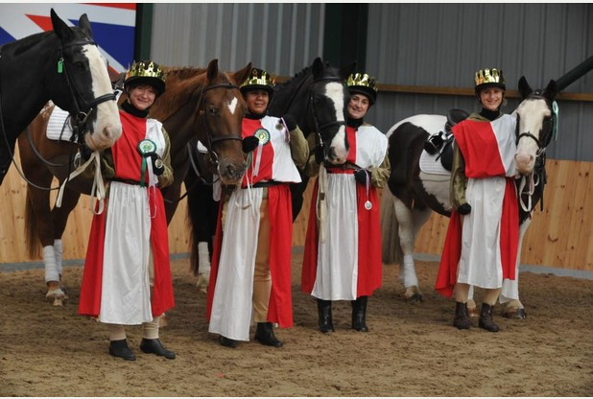
Hopefully you as a rider are familiar with the following experience: life’s small annoyances are getting to you, you are agitated and tomorrow’s worries are bugging you today and on top of it all you have to exercise! You are going horse riding to be exact. At the beginning your mind is everywhere except with the horse and you think the horse is not responding to you. Then (hopefully) you are reminded that the horse always responds to its rider and you are riding your state of mind! You let go (as best as you can) of everything in your head and start to focus on the horse and your riding. By the end of the lesson you are tired but satisfied with how you and the horse performed during the lesson and you give him a huge pat. And all those sorrows and annoying thoughts, gone!
Picture 2 Wonderful costumes at the RDA Musical Ride.
This is what I often experience when I go horse riding and I sincerely hope you yourself are also aware of the ‘healing powers’ of horses. It is this that motivated me to sign up as a volunteer for the RDA the moment Kirsty started to organise this for CURC members. People who ride at the RDA all have additional challenges in their life that they have to deal with every moment of the day. On horseback they don’t need to worry about that, thanks to the volunteers and special equipment all they have to do is focus on their partnership with the horse and enjoy the experience!
Last week I was helping a young girl with cognitive problems whom I had helped before and she had more trouble focussing on the tasks a head and remembering them than usual. As I was walking alongside her, I just every now and then repeated to her what she had to do or helped her remember by asking “What are you going to do at C?”. This clearly helped her and she seemed more at ease knowing I was there for her. She rode so much better after that and she was glowing with the joy when she got of the horse. As a “thank you” the horse got a big hug when she had dismounted and I got one as well!!
From riding myself I have learned to focus on the moment and not what I did wrong a minute ago, it helped me communicate better what I want and it motivates me to keep moving forward. From helping at the RDA I have learned the value of support and that asking for help is never a bad thing as it will allow you to grow and do more than you thought possible. Besides that it has also taught me a lot about handling horses and gave me some great new human ánd horse friends! There is a great positive energy in the school as everyone is encouraged to make the most of themselves. I can recommend to everyone to come along sometime and experience this yourself. See with your own eyes that no matter what obstacles you face, with the right attitude everything can be possible!
If anyone is interested in helping out with the RDA then please get in touch with Kirsty on kj292@cam.ac.uk.
PUB QUIZ
Thank you to everyone who came along to the Pub Quiz held at Newnham bar on Sunday 26th October. We had a great turnout with 4 teams battling for some great prizes and hopefully learning a thing or two on the way. Congratulations to our winning team the Welsh Section D’s! We also raised £46.63 for Cambridge RDA so thank you for being so generous.

STASH
Having updated our logo this has given us a good chance to review our club stash. We are currently in the process of changing suppliers so if anyone has any requests for club stash then let us know. Stash orders will be out ASAP, hopefully by the end of next week.
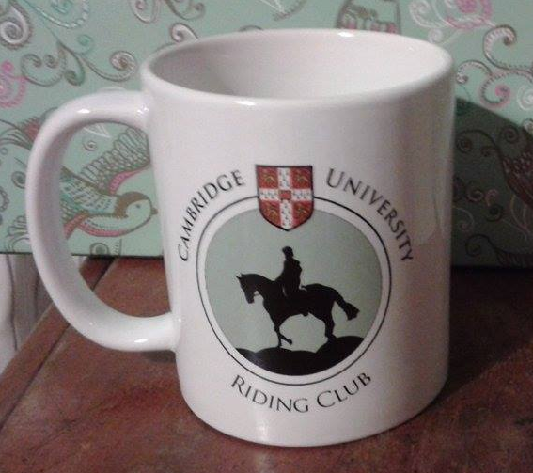
On this subject, anyone who came to the pub quiz will have seen the fabulous CURC mugs that were given out as prizes. If you would like to get your hands on your very own for just £6 then please email Kirsty on kj292@cam.ac.uk. If anyone has planned as far ahead as Christmas they would make great presents and £1 from each mug will be going to support Cambridge RDA.

DATES FOR YOUR DIARY
NOVEMBER | DECEMBER
Thursday 6th Pub meet at The Bath House 7:30pm | w/c 1st Christmas social , more details coming soon
Wednesday 12th Formal at Queens’ College | Tuesday 16th Olympia trip
Sunday 16th Dressage Clinic at Hilltop | JANUARY
Sunday 30th Dressage Cuppers at Hilltop | Sunday 18th Side saddle lessons

